* <https://www.engineersgarage.com/arduino-based-emg-monitor-ad8226/>
* <https://www.instructables.com/Muscle-EMG-Sensor-for-a-Microcontroller/>
* <https://www.google.com/search?q=AD8226+EMG+sensor%C2%A0&client=safari&sca_esv=1ae73ec7be0031ba&sca_upv=1&rls=en&sxsrf=ACQVn0-TF3pkXQPKmMKEUoKMW1F5NClHcA%3A1712004913858&ei=MR8LZreDNNm-0PEP2LCyuA0&ved=0ahUKEwj33_ml86GFAxVZHzQIHViYDNcQ4dUDCA8&uact=5&oq=AD8226+EMG+sensor%C2%A0&gs_lp=Egxnd3Mtd2l6LXNlcnAiE0FEODIyNiBFTUcgc2Vuc29ywqAyBBAjGCcyBhAAGBYYHjILEAAYgAQYigUYhgMyCxAAGIAEGIoFGIYDMgsQABiABBiKBRiGAzILEAAYgAQYigUYhgMyCxAAGIAEGIoFGIYDSNU5UN8VWMk0cAN4AZABAJgBUKABrQOqAQE2uAEDyAEA-AEBmAIJoALdA8ICChAAGEcY1gQYsAPCAgYQABgHGB6YAwCIBgGQBgiSBwE5oAfXHw&sclient=gws-wiz-serp>

Market Research

* <https://www.coherentmarketinsights.com/market-insight/bruxism-treatment-market-5197>
  + <https://www.globenewswire.com/news-release/2023/03/01/2617903/28124/en/Bruxism-Treatment-Global-Market-Report-2023-Increasing-Prevalence-of-Anxiety-and-Depression-Fuels-Growth.html>
* <https://www.ncbi.nlm.nih.gov/pmc/articles/PMC5070759/>
* <https://www.sleepfoundation.org/bruxism>
  + 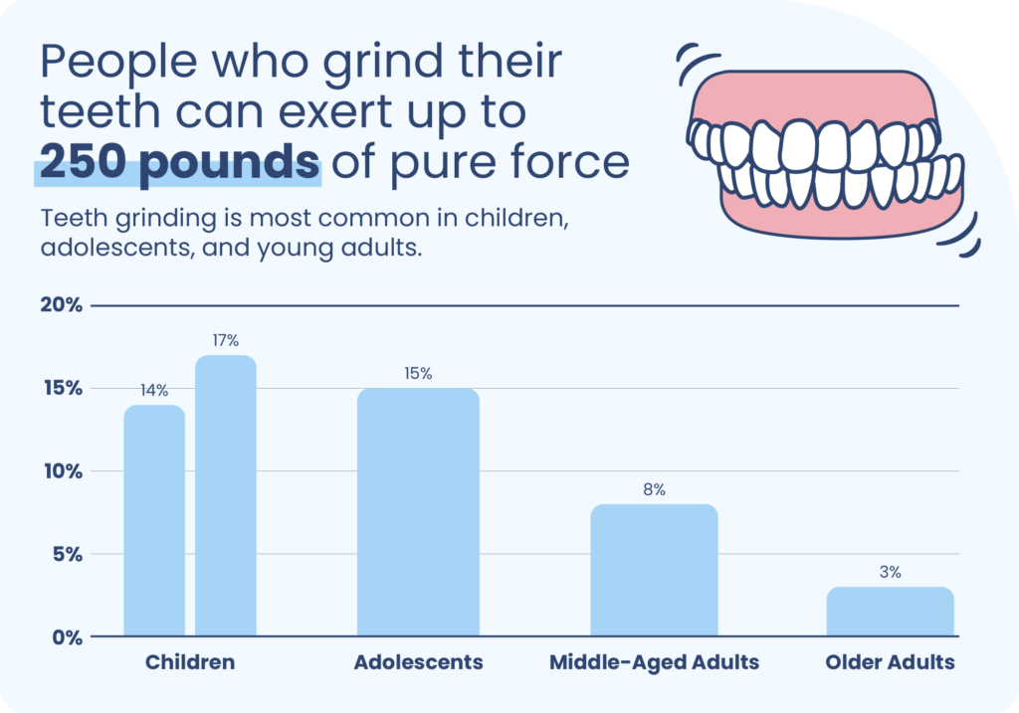
  + References:
    - Yap, A. U., & Chua, A. P. (2016). Sleep bruxism: Current knowledge and contemporary management. Journal of Conservative Dentistry, 19(5), 383–389.  
      <https://pubmed.ncbi.nlm.nih.gov/27656052/>
    - Hennessy, B.J. (2022, February). Teeth grinding. Merck Manual Consumer Version.  
      <https://www.merckmanuals.com/home/mouth-and-dental-disorders/symptoms-of-oral-and-dental-disorders/teeth-grinding>
    - Machado E., Dal-Fabbro C., Cunali P. A., Kaizer O. B. (2014). Prevalence of sleep bruxism in children: A systematic review. Dental Press Journal of Orthodontics.  
      <https://pubmed.ncbi.nlm.nih.gov/25628080/>
    - Gerstner, G. E. (2022, February 3). Sleep-related bruxism (tooth grinding). In A. F. Eichler (Ed.). UpToDate.  
      <https://www.uptodate.com/contents/sleep-related-bruxism-tooth-grinding>
    - Prado I.M., Abreu L.G., Silveira K.S., Auad S.M., Paiva S.M., Manfredini D., Serra-Negra J.M. (2018). Study of associated factors with probable sleep bruxism among adolescents. Journal of Clinical Sleep Medicine, 14(8), 1369-1376.  
      <https://pubmed.ncbi.nlm.nih.gov/30092895/>
    - Hennessy, B.J. (2022, February). Bruxism. Merck Manual Consumer Version.  
      <https://www.merckmanuals.com/professional/dental-disorders/symptoms-of-dental-and-oral-disorders/bruxism>
    - MedlinePlus: National Library of Medicine (US). (2022, January 24). TMJ disorders.  
      <https://medlineplus.gov/ency/article/001227.htm>
    - Wieckiewicz M., Paradowska-Stolarz A., Wieckiewicz W. (2014). Psychosocial aspects of bruxism: The most paramount factor influencing teeth grinding. BioMed Research International.  
      <https://pubmed.ncbi.nlm.nih.gov/25101282/>
    - Martynowicz, H., Gac, P., Brzecka, A., Poreba, R., Wojakowska, A., Mazur, G., Smardz, J., & Wieckiewicz, M. (2019). The Relationship between Sleep Bruxism and Obstructive Sleep Apnea Based on Polysomnographic Findings. Journal of clinical medicine, 8(10), 1653.  
      <https://pubmed.ncbi.nlm.nih.gov/31614526/>
    - Ohayon M.M., Li K.K., Guilleminault C. (2001) Risk factors for sleep bruxism in the general population. Chest, 119(1), 53-61.  
      <https://pubmed.ncbi.nlm.nih.gov/11157584/>
    - Herrero Babiloni A., Lavigne G.J. (2018). Sleep bruxism: A “bridge” between dental and sleep medicine. Journal of Clinical Sleep Medicine, 14(8), 1281-1283.  
      <https://pubmed.ncbi.nlm.nih.gov/30092910/>
    - Schwab, R. J. (2022, May). Snoring. Merck Manual Professional Version.  
      <https://www.merckmanuals.com/en-pr/professional/neurologic-disorders/sleep-and-wakefulness-disorders/snoring>